Join Us for an Unforgettable Experience in 2020 for an Israel Tour!
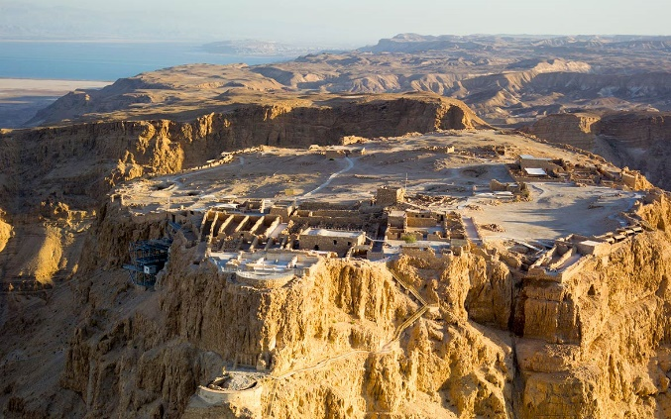
After a trip to Israel, you never will look at life the same way!
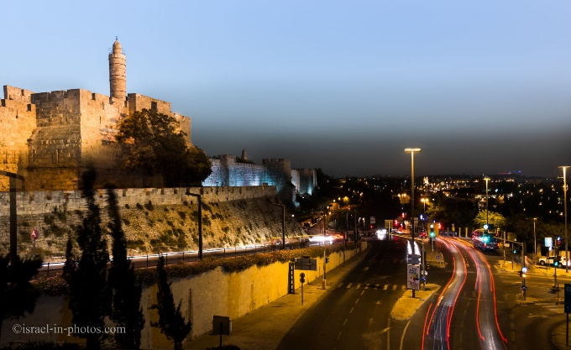
- When you have walked in Jerusalem and think about what happened as Jesus lived there…
- When you view the Sea of Galilee for yourself for the first time…
- When you stop and examine the spot where the temple was built and consider that the Glory of God was literally right there…
- When you see culture, different people groups living together in Jerusalem…
- When you see cultural, biblical and historical sights, it’s like you’re there as it happened over 2000 years ago…
It will enhance your Historical, Cultural, Biblical view and Perspective! You have a point of reference and you remember it when you read about those places and events in your Bibles!
If you’ve never been to Israel, make it your goal to get there!
It’s been said that “a trip to Israel is equal to a semester of bible college!”
We’re going January 3 – January 13, 2020 and will cover tons of breathtaking, historical, cultural and biblical sights!

Make your $200 deposit now to secure your spot!
Total cost: $2750.00 (includes Airfare (from USA), Hotels, Tours, Tips for driver, Tour Guide, Hotel staff & Meals during the tour, Breakfast/Dinner@hotels and majority of lunches out during our travels!)

(please contact Pastor Tom@ ptom@calvarycw.org for more information)

